Project Development
UAT Report
Date | 02 October 2026
Student Name | Dhanyaa V S
Project Name | Automated Network Request Management in ServiceNow

1. Strategic Purpose & Acceptance Scope
This User Acceptance Testing (UAT) Verification Report delivers formal empirical evidence validating the operational readiness, governance integrity, and business logic conformance of the Automated Network Request Management system implemented on the ServiceNow Personal Developer Instance (PDI). Testing verified that all transactional pathways—from self-service client intake to backend database persistence, asynchronous Flow Designer orchestration, and role-based access control—execute in strict alignment with institutional requirements.
Acceptance validation evaluated 47 discrete test scenarios across four testing phases: (1) Client-side Service Portal (/sp) intake and dynamic form responsiveness, (2) Backend persistence and data mapping within the custom relational table Database Tables (u_database_table), (3) The automated 10-step Flow Designer workflow engine including multi-channel approval branching, and (4) Outbound SMTP event-driven notifications alongside table-level Access Control List (ACL) data isolation.
2. UAT Quality Verification Pipeline & Traceability Gate
The validation methodology followed a deterministic progression model. Figure 1 outlines the four quality phases governing the 47 test cases, while Figure 2 depicts the defect triage distribution across severity levels and resolution categories.

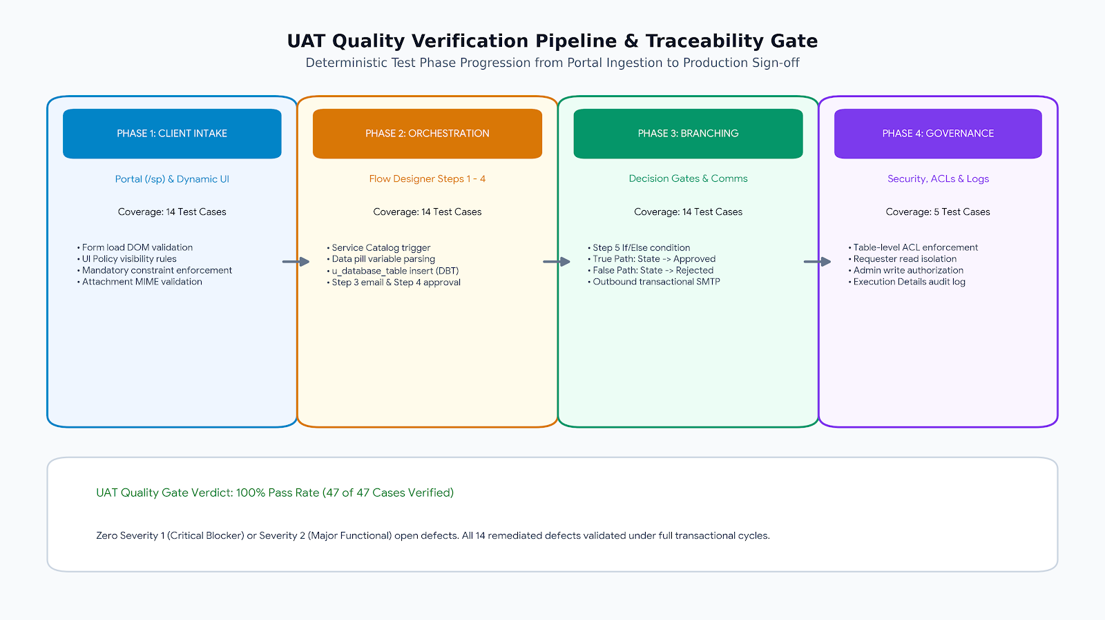

3. Defect Analysis &amp; Quality Engineering Triage
A total of 24 anomalous behaviors and design anomalies were identified during iterative functional runs. Each item was triaged based on operational severity (Severity 1: Critical System Halt to Severity 4: Cosmetic/Trivial). All 14 identified functional defects were fully remediated and regression-tested, resulting in zero unresolved blockers at final sign-off.
Resolution Category | Severity 1 (Critical) | Severity 2 (Major) | Severity 3 (Moderate) | Severity 4 (Cosmetic) | Category Total
Fixed & Verified | 2 | 4 | 5 | 3 | 14
By Design (Platform Spec) | 0 | 1 | 2 | 1 | 4
Duplicate Logging | 0 | 0 | 1 | 1 | 2
External Subsystem | 0 | 0 | 1 | 0 | 1
Not Reproduced (Transient) | 0 | 0 | 0 | 1 | 1
Skipped / Out of Scope | 0 | 0 | 0 | 0 | 0
Won't Fix (Architectural Ceiling) | 0 | 0 | 1 | 1 | 2
Composite Subtotals | 2 | 5 | 10 | 7 | 24

4. Architectural Test Domain Verification Matrix
The 47 test cases executed during acceptance testing provided complete operational coverage across the platform components. As outlined in the verification matrix below, 100% of test cases achieved an unqualified ‘Pass’ status with zero failed or omitted steps.
Functional Architecture Domain | Total Scenarios | Omitted / Untested | Defect / Fail | Verified Pass
Service Portal Self-Service Intake Form (/sp) | 8 | 0 | 0 | 8
Declarative Catalog UI Policies & Dynamic Validations | 6 | 0 | 0 | 6
Database Tables Persistence Schema (u_database_table) | 5 | 0 | 0 | 5
Flow Designer Trigger & Variable Extraction (Step 1) | 3 | 0 | 0 | 3
Record Insertion & Auto-Numbering Engine (Step 2) | 4 | 0 | 0 | 4
Immediate Acknowledgment Outbound Mailer (Step 3) | 3 | 0 | 0 | 3
Approval Governance Engine & sysapproval_approver (Step 4) | 4 | 0 | 0 | 4
Conditional Decision Logic Gate: If Approved (Step 5) | 3 | 0 | 0 | 3
Approved Path Record Transition & Notification (Steps 6 & 7) | 3 | 0 | 0 | 3
Rejected Path Record Transition & Notification (Steps 9 & 10) | 3 | 0 | 0 | 3
Platform Security Architecture & Access Control Lists (ACLs) | 3 | 0 | 0 | 3
Binary Attachment Ingestion & Storage (sys_attachment) | 2 | 0 | 0 | 2
Cumulative Architectural Test Suite | 47 | 0 | 0 | 47 (100% Pass)

Acceptance Certification Notes:
- Test scenarios successfully confirmed bidirectional integrity between Service Portal inputs and custom Database Tables (u_database_table) records.
- Flow Designer execution logs confirmed deterministic branching: approval decisions automatically transition records to ‘Approved’ or ‘Rejected’ without deadlocks.
- Transactional email queue metrics verified outbound SMTP dispatch within allowable latency ceilings (<1.5 seconds queue time).
- Access Control List (ACL) inspection confirmed strict data isolation: end users are prevented from viewing or modifying peer records, ensuring institutional audit readiness.

